21 DAYS OF EASTER

Preparing for
THE RESURRECTION
(A Spiritual Growth Fast)

This packet belongs to: _________________________________

Please invite and bring two friends to church on
Easter Sunday!

What is the 21 Days of Easter and why are we doing it?
- The 21 Days of Easter is a spiritual growth fast and is about glorifying God through focusing on healthy eating, weight loss, and exercise while attending weekly Bible Study.

- Days 1-10: The first 10 days are about eliminating our ungodly ways that keep us from looking like Jesus. The unhealthy foods we eliminate serve as constant reminders throughout the day that we are trusting God to eliminate our ungodly or toxic ways. Symbolically, we have eliminated meats and fatty foods as we eat healthy, plant-based meals to represent the elimination of personal ungodliness. You can sum up the first 10 days in two words, “Ungodliness Out!” What does God want to see less of in your life?

- Days 11-21: The last 11 days are about increasing our godly ways and looking more like Christ. The healthy foods we eat serve as constant reminders throughout each day that we are relying on God and His word to increase godliness in us, so that we can grow spiritually and look more like His Son Jesus. Symbolically, we add lean meats and healthy fats to our meals to represent increasing personal godliness. The goal for the last 11 days is “Godliness In!” What does God want to see more of in your life?
FAQ’s
(Frequently Asked Questions)
- If I’m stuck in my spiritual growth, what can I do? God uses four steps to grow us spiritually. Connect with Christ through worship, giving and prayer. Grow in Community by studying God’s word with others. Serve with Compassion by getting involved in your church. Go witness for Christ by telling others all that Jesus has done for you. In summary: Attend! Give! Serve! Witness! Live holy!
- What is the 21 Days of Easter? The first 10 days we will ask God to purge our souls and bodies of the toxins hindering our lives. The next 11 days leading to Easter Sunday morning we will ask God to fill us with the spiritual and physical nutrition we need to grow in Christ and live a resurrected life.
- Do I get to eat? Yes! You’ll be eating healthy foods, primarily plant-based the first 10 days (like a Daniel’s fast) and healthy foods including low fat meats the last 11 days until breakfast on Easter Sunday morning. We’ll provide menu suggestions.
- Do I have to add meat back into my diet during the last 11 days? No. Many people have chosen to continue with the plant-based diet for the entire 21 days, and beyond!
- What if I have nutrition and meal planning questions? Nurses will be available every Sunday after church to answer your questions.
- Cost? Free! Just commit to grow in Christ by growing in community.
- Where can I find more information? Follow us on FaceBook and visit our website during the 21 days for the daily inspiration and ideas to help you move closer to Christ.

DEVOTIONAL MATERIALS
Online Readers
YouVersion Devotional Reading: 21 Day Fast
- Step 1: Click here http://bible.com/r/Z.1
or visit www.bible.com/sign-up to sign up.
  - Mobile device users go to Google Play Store to download The Bible app by YouVersion (LifeChurch.tv).
- Step 2: Type the name of your devotional reading in the search box. Click the name.
- Step 3: Click “start this plan.”
- Step 4: Visit our website at www.get-Truth.org to download your 21 Days of Easter packet.
- Step 5: Follow us on FaceBook at http://ow.ly/vaiUm. Join the conversation!

Offline Readers
Offline: 21 Days in the Book of Mark
❑ | Mark 1:1-28 | Day 1
❑ | Mark 1:29-2:13 | Day 2
❑ | Mark 2:14-3:12 | Day 3
❑ | Mark 3:13-4:12 | Day 4
❑ | Mark 4:13-41 | Day 5
❑ | Mark 5 | Day 6
❑ | Mark 6:1-32 | Day 7
❑ | Mark 6:33-7:13 | Day 8
❑ | Mark 7:14-37 | Day 9
❑ | Mark 8 | Day 10
❑ | Mark 9:1-29 | Day 11
❑ | Mark 9:30-10:16 | Day 12
❑ | Mark 10:17-52 | Day 13
❑ | Mark 11 | Day 14
❑ | Mark 12 | Day 15
❑ | Mark 13:1-23 | Day 16
❑ | Mark 13:24-14:21 | Day 17
❑ | Mark 14:22-52 | Day 18
❑ | Mark 14:53-72 | Day 19
❑ | Mark 15:1-41 | Day 20
❑ | Mark 15:42-16:20 | Day 21! Congratulations!

SPIRITUAL GROWTH
Bible Study

Grow in Community!

People grow better and faster together. In Genesis 2:18 God said, “It’s not good for man (people) to be alone.” God created us to be in constant fellowship with one another around Him and His word. Although food is a big part of everyone’s day, spiritual growth is the primary emphasis of our spiritual growth fast. So, partner with someone during your spiritual growth fast. Share ideas. Encourage one another. Pray for and with each other.

MEAL PLANNER
What should I eat? Look at the picture of what your lunch and dinner plate should look like during this spiritual growth fast. We’ve simplified your meal plans, so that you can focus on what’s most important- getting to know God better, so that you can grow spiritually. This section focuses on your lunch and dinner. Breakfast and snack suggestions are provided in the back of this packet.
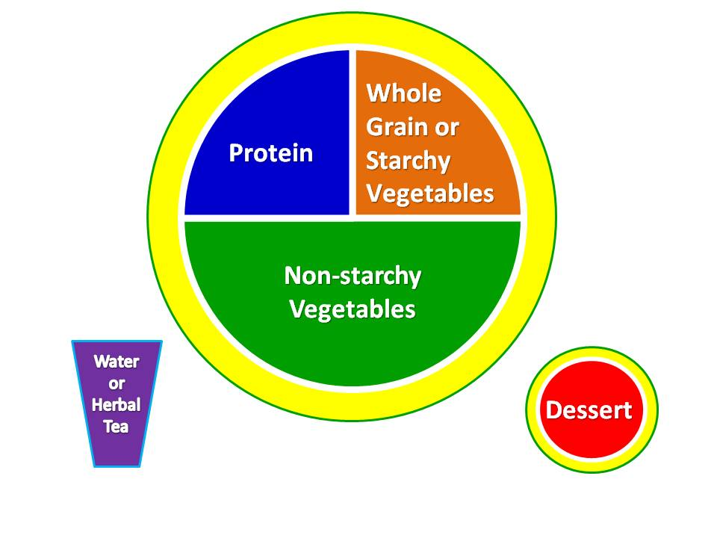
- Step 1: Pick your Protein. It will comprise 25 % of your meal plate. The first 10 days you will eat plant-based proteins. The last 11 days you may add lean animal proteins (meat, fish, poultry, seafood). See the handout, Build a Healthy Lunch or Dinner.
- Step 2: Pick your Non-Starchy Vegetables. They will comprise 50 % of your meal. This is the healthiest part of your nutrition plan. Be sure to keep this a priority every day. See the handout, Build a Healthy Lunch or Dinner.
- Step 3: Pick a Whole Grain or Starchy Vegetables. They will comprise 25 % of your plate. Your body needs healthy carbohydrates (good sugars) to produce energy efficiently. However, most people include too much bad sugar in their diet. Many times they make unhealthy choices and choose junk food type sugars. This part of your meal will provide you with all the energy you need and it will be good for your body and brain. See the handout, Build a Healthy Lunch or Dinner.
- Step 4: Pick a healthy Drink. Water is the healthiest drink, especially during the first 10 days, because it will help cleanse the toxins from your body. The goal of the first 10 days is to eliminate all drinks that are bad for your system, such as beverages with sugars, caffeine, alcohol and processed chemicals. You may also drink herbal tea during the entire 21 days. You may re-introduce fruit juices and other healthy drinks during days 11-21. See the handout, Build a Healthy Lunch or Dinner.
- Step 5: Pick a healthy DesSert. The desserts can also serve as snacks. We have chosen tasty sweets that God has created for our enjoyment. The challenge for many today is that they are addicted to man-made treats instead of God-made sweets. Try to eliminate all junk food during the 21 day spiritual growth fast. Let this be symbolic of your efforts to crucify your flesh (Galatians 5:24). See the handout, Build a Healthy Lunch or Dinner.
Build A Healthy Lunch or Dinner

Step 1: Pick your Protein.
Days 1-10 (The plant protein combos below provide the same nutrition as meats and fish but without unhealthy fats.)

- Quinoa (“keen-wah”)*
- Veggie Burgers
- Veggie Patties
- Any Plant-based Protein
- Brown Rice plus Beans
- Brown Rice plus Nuts
- Brown Rice plus Seeds
- Brown Rice plus Wheat
- Beans plus Nuts
- Beans plus Seeds
- Beans plus Wheat

* = Super Foods! (also BEANS)

Days 11-21

Healthiest Proteins
- Any protein combo from above

Poultry
- Chicken (skinless)
- Chicken (ground white meat)
- Turkey (skinless)
- Turkey (ground white meat)

Fish
- Salmon (wild)
- Tuna (low-mercury)
- Flounder
- Haddock
- Trout
- Herring
- Mackerel
- Sardines
- Snapper

Meats
- Beef (lean)
- Lamb

Seafood
- Shrimp
- Scallops
- Oysters
- Clams
- Crab

Step 2: Pick your Non-Starchy Vegetables.

- Avocado*
- Kale*
- Lettuce
- Broccoli
- Cauliflower
- Spinach
- Green Beans
- Cabbage
- Collard Greens
- Cucumbers
- Celery
- Bell Peppers
- Asparagus
- Zucchini
- Jalapeño pepper
- Radishes

Step 3: Pick a Whole Grain or Starchy Vegetables.

- Brown Rice*
- Black Rice
- Sweet Potatoes
- Potatoes
- White Rice
- Green Peas
- Corn
- Carrots
- Winter Squash
- Turnips
- Lentils
- Beans (Legumes)
- Split Peas
- Chickpeas

Step 4: Pick a healthy Drink.
Days 1-10 (unsweetened and caffeine-free)

- Water*
- Herbal Tea

Sweeteners
- Stevia or Agave

Days 11-21

- Any drink from above
- Fruit juice
- Almond Milk (unsweetened)
- Coconut Milk (unsweetened)
- Rice Milk (unsweetened)
- Soy Milk (unsweetened)
- Coconut Milk (unsweetened)
- Black Tea (decaf)
- Coffee (decaf)

Sweeteners
- Stevia or Agave
- Raw Honey

Step 5: Pick a healthy DesSert. (Low glycemic fruits and berries*)

- Apple
- Banana
- Orange
- Peaches
- Apricots
- Plum
- Strawberries
- Cherries
- Blueberries
- Blackberries
- Raspberries
- Kiwi
- Nectarines
- Tomatoes
- Guava
- Grapefruit (check with pharmacist if on medication)

nourishing BREAKFAST IDEAS

Days 1-10

- Quinoa (grain) w/coconut, cinnamon & chopped almonds
- Oatmeal w/almond milk and fruit
- Granola (no added sugar)
- Cream of Wheat
- Fruit bowl w/Nuts
- Banana, Strawberries and Nuts
- Apple w/Pecans and/or Almonds
- Protein Shake
- Pineapple Banana Smoothie
- Strawberry Banana Smoothie
- Bran Muffin

Days 11-21

- Any breakfast from days 1-10
- Eggs w/lean meats and fruit
- Greek yogurt w/fruit
- Whole wheat toast w/peanut butter & fruit
- Whole grain toast w/almond butter & fruit

DELICIous LUNCH & DINNER IDEAS

Days 1-10 (unsweetened and caffeine-free)

- Salads
- Veggie Wraps
- Kale and White Bean Soup
- Vegetarian Spaghetti
- Vegetable Soup
- Vegetarian Chili
- Stuffed Peppers with Quinoa
- Vegetable Stir Fry
- Zucchini Lasagna
- Veggie Burger
- Veggie Pattie
- Peanut Butter
- Almond Butter
- Protein Shake

Days 11-21

- Turkey Wrap with lettuce and cucumber
- Baked chicken breast with baked or sweet potato and vegetables
- Baked fish with zucchini and onions
- Chicken stir fry with peppers and onions
- Chicken and broccoli over brown rice
- Fish Tacos
- Hummus dip with vegetables
- Mexican dishes (not deep fried, no dairy)
- Indian dishes (not deep fried)
- Any lunch or dinner idea from days 1-10

nutritious snacks

- Fruit
- Almonds
- Almond Butter
- Brazil Nuts
- Cashews
- Hazelnuts
- Macadamia Nuts
- Pecans
- Pine Nuts
- Pistachios
- Walnuts
- Applesauce (unsweetened)
- Dark chocolate (1-2 squares, 20 grams)
- Dried Fruit (1-2 small pieces)
- Popcorn (unbuttered)

